Operating instructions

1. Open the software

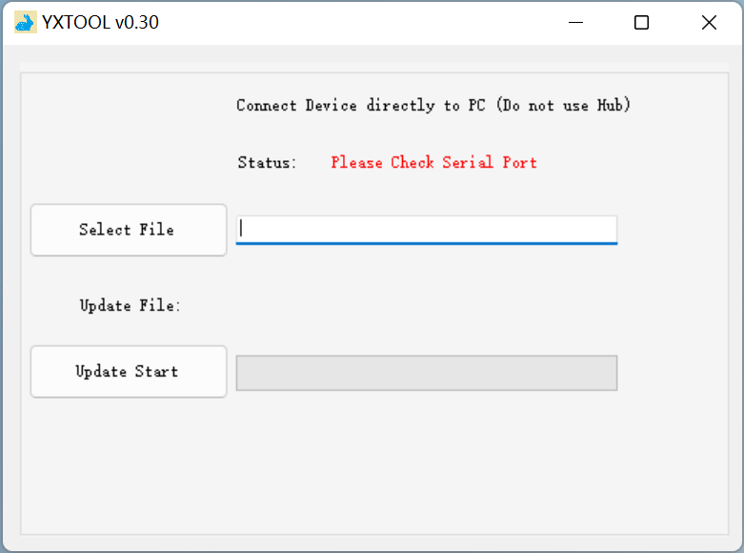

1. Waiting for connection

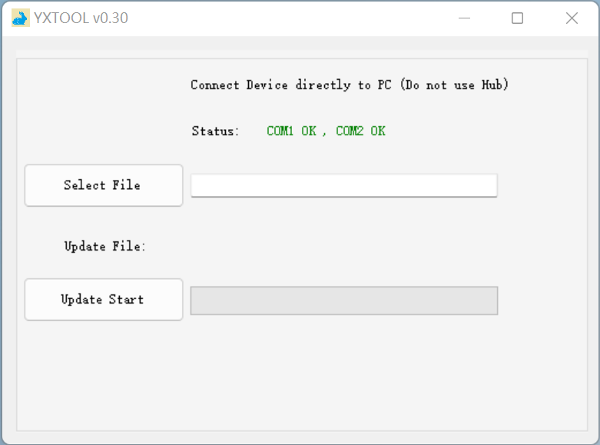

1. Select mix file

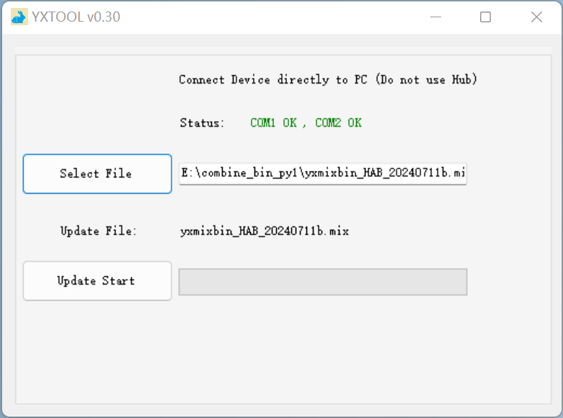

1. Check the file name and download

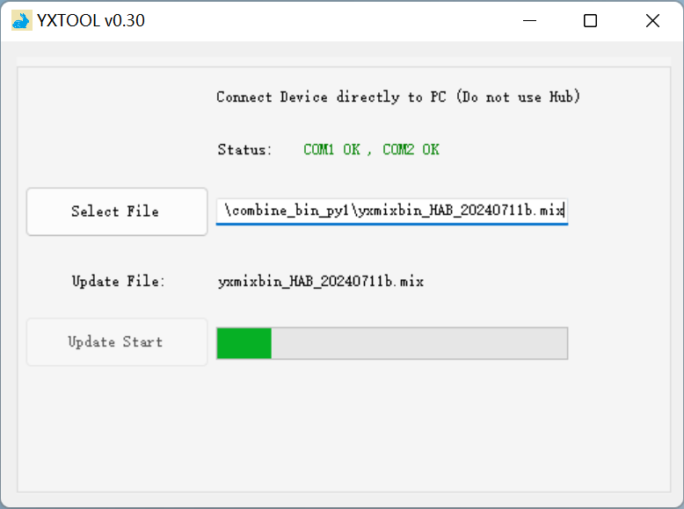

1. Download completed

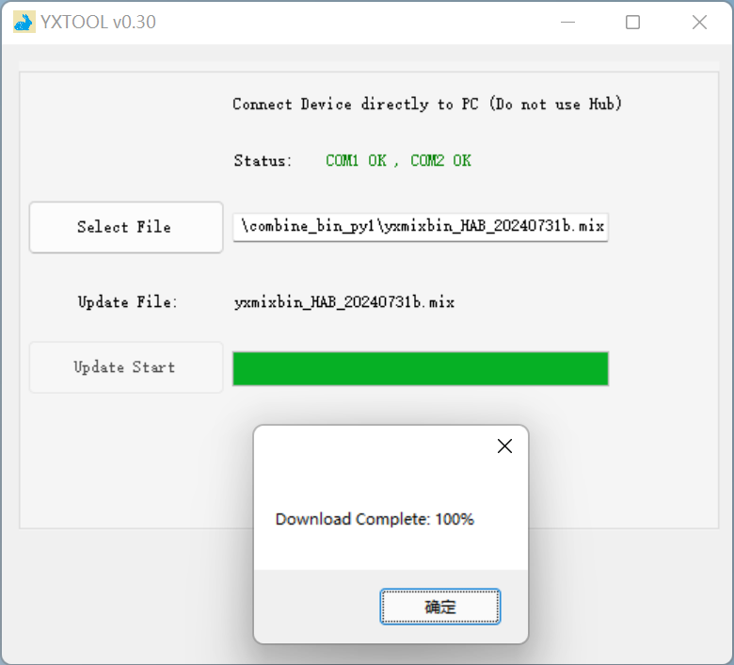

**Note**：If the device disconnects during the download process and the download is interrupted, please reconnect the device after the countdown ends, wait for the serial port to connect and download.

